**Data analysis:**

# Main inference Male Vs Female Vs Industry:

How the industry wide disparity exists between Male Vs Females in various industries. Males are paid higher in most of the industries irrespective of the type of industry. This is common across states all over Australia. In certain industries males are paid almost two times in wages compared to the female counter parts.

**Data taken from:**

1. [Taxation Statistics 2020-21 – Individuals Table 5: Selected items, by sex, state/territory and broad industry, 2020–21 income year](https://data.gov.au/data/dataset/07b51b39-254a-4177-8b4c-497f17eddb80/resource/4965b0a0-6202-46f9-b2a4-ae310cb6377f/download/ts21individual05sexstateterritorybroadindustry.xlsx)

South Australia.

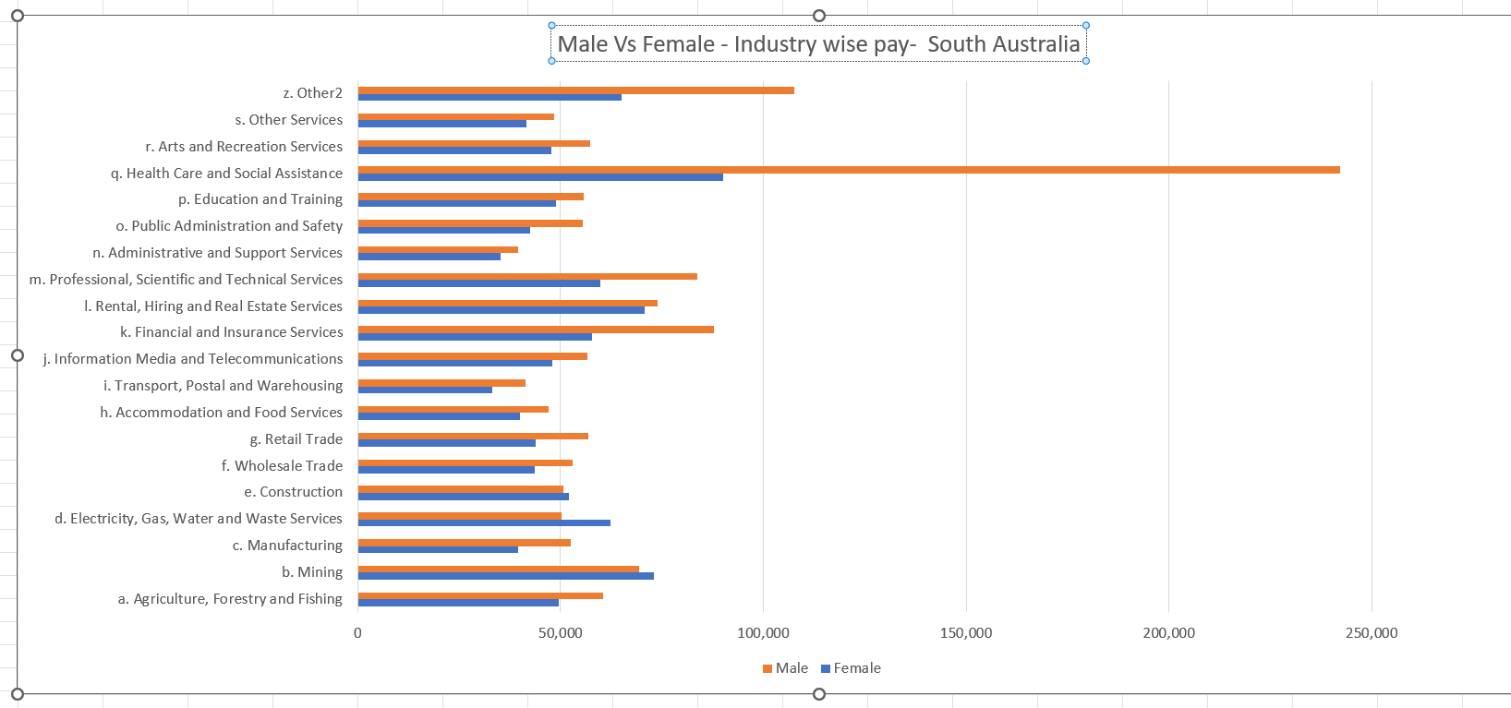

Western Australia

